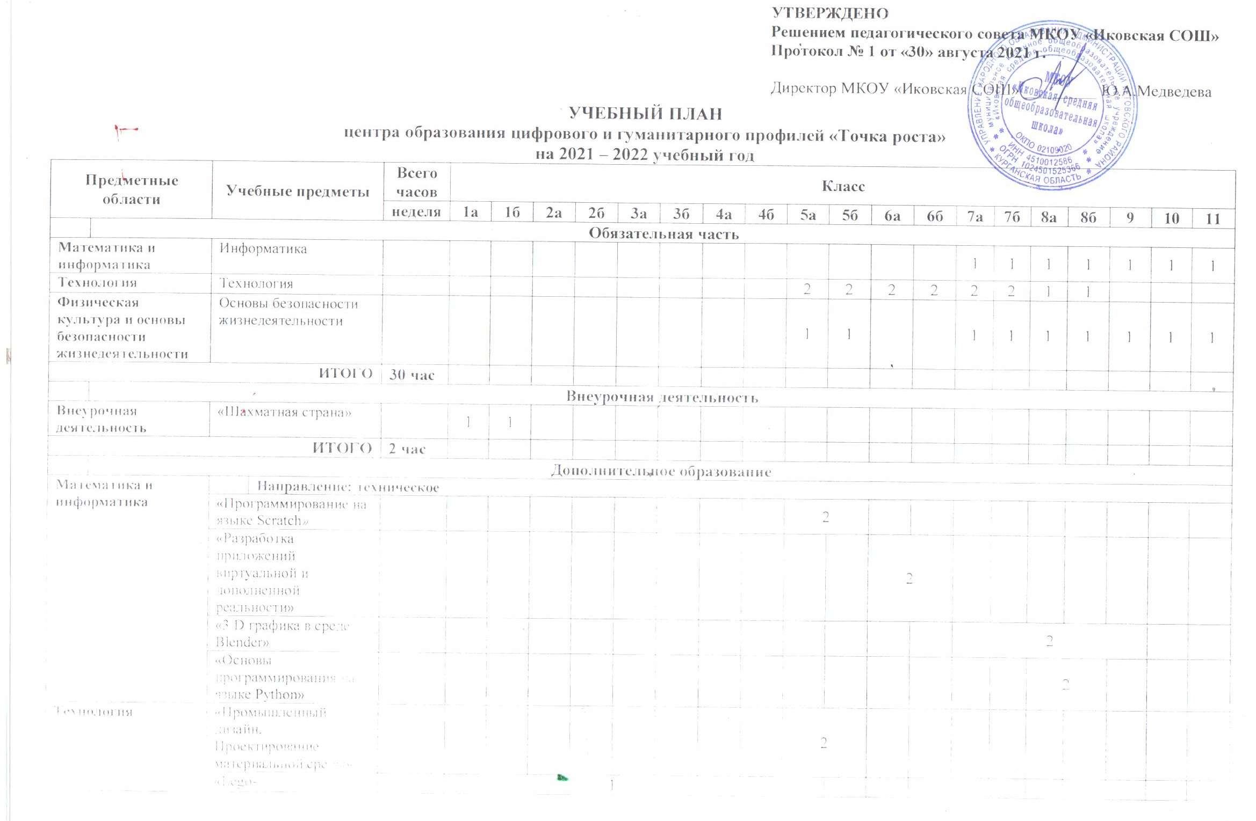

|  |  |  |  |  |  |  |  |  |  |  |  |  |  |  |  |  |  |  |  |  |  |  |  |
| --- | --- | --- | --- | --- | --- | --- | --- | --- | --- | --- | --- | --- | --- | --- | --- | --- | --- | --- | --- | --- | --- | --- | --- |
| **Физическая культура и основы безопасности жизнедеятельности** |  | **Направление: физкультурно-спортивное** | | | | | | | | | | | | | | | | | | | | | |
| «Шахматная страна» | |  |  |  | 1 | 1 | 1 | 1 | 1 | 1 |  |  |  |  |  |  |  |  |  |  | |  |
| «Шахматы» | |  | 1 | | | | | | | | | | | | | | | | |  | |  |
|  |  | **Направление: естественнонаучное** | | | | | | | | | | | | | | | | | | | | | |
| «Научная лаборатория - Науколаб» | |  |  |  |  |  |  |  |  |  | 1 |  | 1 |  |  |  |  |  |  |  | |  |
|  |  | **Направление: социально-педагогическое** | | | | | | | | | | | | | | | | | | | | | |
| «Финансовая грамотность» | |  |  |  |  |  |  |  |  |  |  |  |  |  |  |  | 2 | |  |  | |  |
| ИТОГО | | | **22 час** |  |  |  |  |  |  |  |  |  |  |  |  |  |  |  |  |  | |  |  |